**NOTE: Fill this document according to the requirements that you have identified in your analysis and brain storming.**

Software Requirements Specification

For

GuardarComida: An Online Food Waste Management System for Hospitality Services

**Version 1.0 approved**

**Prepared by:**

**Bauyon, John Lambert A.**

**Erilla, Jomira Joy G.**

**Visto, Dave B.**

**ENCLOUDERS**

**July 07, 2021**

**Table of Contents**

**Table of Contents ii**

**Revision History ii**

**1. Introduction 1**

1.1 Purpose 1

1.2 Document Conventions 1

1.3 Intended Audience and Reading Suggestions 1

1.4 Project Scope 1

1.5 References 1

**2. Overall Description 2**

2.1 Product Perspective 2

2.2 Product Features 2

2.3 User Classes and Characteristics 2

2.4 Operating Environment 2

2.5 Design and Implementation Constraints 2

2.6 User Documentation 2

2.7 Assumptions and Dependencies 3

**3. System Features 3**

3.1 System Feature 1 3

3.2 System Feature 2 (and so on) 4

**4. External Interface Requirements 4**

4.1 User Interfaces 4

4.2 Hardware Interfaces 4

4.3 Software Interfaces 4

4.4 Communications Interfaces 4

**5. Other Nonfunctional Requirements 5**

5.1 Performance Requirements 5

5.2 Safety Requirements 5

5.3 Security Requirements 5

5.4 Software Quality Attributes 5

**6. Other Requirements 5**

**Appendix A: Glossary 5**

**Appendix B: Analysis Models 6**

**Appendix C: Issues List 6**

**Revision History**

|  |  |  |  |
| --- | --- | --- | --- |
| **Name** | **Date** | **Reason For Changes** | **Version** |
|  |  |  |  |
|  |  |  |  |

# Introduction

## Purpose

The GuardarCommida: An Online Food Waste Management for Hospitality Service will provide a service that organize or manage the foods and gives notification to the user if the food is about to expire.

The 30% of this system was to login the user who have access the system. It can input all the data about a specific product or food. It requires a lot of data of food to easily manage and categorized in different type of food such as frozen foods or can goods.

## Document Conventions

The documentation convention that we used are:

* Font Style: Times New Roman
* Font Size: 13
* Spacing: Double Spacing
* Reference format: MLA or Modern Language Association

## Intended Audience and Reading Suggestions

The expected audience that relates to our program or system will be the chefs, waiters or crews and the system developer and those who are belong to the hospitality services. This audience will benefit the system as well and they are the one that apply it on their job or professions.

## Project Scope

* Login Form
* User information
* Input food details
* Food request form
* Table for List of foods

## References

HTML, <https://developer.mozilla.org/en-US/docs/Learn/Getting_started_with_the_web/HTML_basics>

Database <https://www.britannica.com/technology/database>

Xampp<https://undsgn.com/xampptutorial/#:~:text=XAMPP%20is%20an%20abbreviation%20for,web%20server%20on%20your%20computer>.

WWW <https://www.britannica.com/topic/World-Wide-Web>

Narvanen, Elina, et al. SpringerLink. 04 September 2019. April 2021. <<https://link.springer.com/chapter/10.1007/978-3-030-20561-4_1>>. Olanigan, Ibrahim. "DESIGN AND IMPLEMENTATION OF FOOD MANAGEMENT SYSTEM ON ANDROID PLATFORM WITH QR CODE SUPPORT." (2013).

# Overall Description

## Product Perspective

The GuardarComida can be used under Hospitality Services wherein they serve food to people and it can be categorized in business because in managing food waste we can also prevent the money lost in business under hospitality services. It is because wasting food is equivalent to wasting money. This system help the hospitality services in monitoring and managing their food inventory so we can prevent food expiration. It is a replacement or enhancement of certain existing systems.

## Product Features

* Login Form
* Food Request Form
* Manage Food Stock

## User Classes and Characteristics

The users for this product are:

* Admin
* Manage Food Inventory
* Process Request (Accepting Supply Request)
* View Food Supply Information
* View Food Waste
* View Reports
* Staff, Cook/chief
* Request Food Supply
* Fill up Food Waste Form

## Operating Environment

The developed system is an independent platform and it can exist without other system.

## Design and Implementation Constraints

The issues that will limit the options of the developers in this product is the regulatory policies and the business process that the hospitality services have. And if the hospitality services will adapt and willing to use the develop system for managing food waste.

## User Documentation

*<List the user documentation components (such as user manuals, on-line help, and tutorials) that will be delivered along with the software. Identify any known user documentation delivery formats or standards.>*

## Assumptions and Dependencies

*<List any assumed factors (as opposed to known facts) that could affect the requirements stated in the SRS. These could include third-party or commercial components that you plan to use, issues around the development or operating environment, or constraints. The project could be affected if these assumptions are incorrect, are not shared, or change. Also identify any dependencies the project has on external factors, such as software components that you intend to reuse from*

# System Features

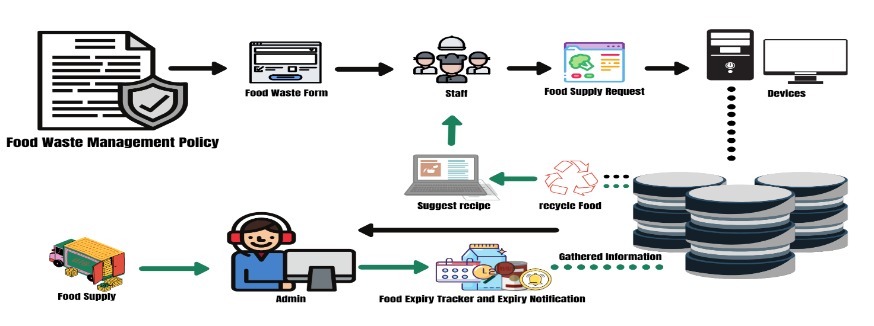

## Login Form

3.1.1 Description and Priority

This feature will play a vital part of our system which provide security when it terms to user accessibility between admin and staff as well as authentication for unexpected access from any kinds of attacks for unauthorized person. This would be high priory features which scale of level 9, specially our system we develop will dealing so many important data and information’s.

3.1.2 Stimulus/Response Sequences

*- Fill-up fields with USERID and password*

*- click login button*

*- If wrong do step 1 and 2*

3.1.3 Functional Requirements

The basic requirement for this features in order to surpass the authentication form is in the following: first valid user ID and also valid user password if user enters wrong password and user ID the system will immediately pop up the dialog box which contains an information of invalid input or errors and inform user to re-attempt login.

REQ-1: USERID

REQ-2: USERPASSWORD

## Manage Food Stock

### Description and Priority

This Feature is one of the main feature of our system which deals a process of managing food stocks which provide additional sub features such as Add, Update, Delete, and View Features. This would be also a high priority features which scale of level 9, responsible for the process and operations happens to the system especially on dealing data and information’s of every food stock.

3.2.2 Stimulus/Response Sequences

- Add Food stock

- Edit Food Stock

- delete Food stock

- View Food stock

3.2.3 Functional Requirements

The basic requirement for this feature is the data and information of every food stock, which is critical for the system in order to begin a process and operation, that would be the main purpose of the system which design to be developed as a system has the ability to reduce food waste by assisting users, particularly staff and admin, to properly and detailed manage their food stock. This features provide a different dialog box contains of information of every user actions such as invalid data input, errors, and asking user actions for decision making.

REQ-1: Data of food stock

REQ-2: Information of food stock

## Food Request Form

### Description and Priority

This Feature is responsible of the process in requesting food stock between staff to admin, it is necessary feature with high priority which scale of level 8. Specially the system will help to assist staff to be organize and detailed when it comes of using their stocks.

3.3.2 Stimulus/Response Sequences

- Fill-up every fields

- put all data and information of food stocks wants to request

- Click request button once done to fill-up

3.3.3 Functional Requirements

The basic requirement for this feature is the data and information of food stock want to request by the staff to admin, the process will begin to form a transaction between admin and staff the main purpose of this operation is to have a detailed and proper management of every food stock to reduce the increasing food wastage of hospitality services. This process takes a minutes or seconds only and every transaction will proceed to database of reports wherein admin can generate report details of every food request success and fail transactions.

REQ-1: Data of food stock

REQ-2: Information of food stock

# External Interface Requirements

## User Interfaces

**Admin Interface**

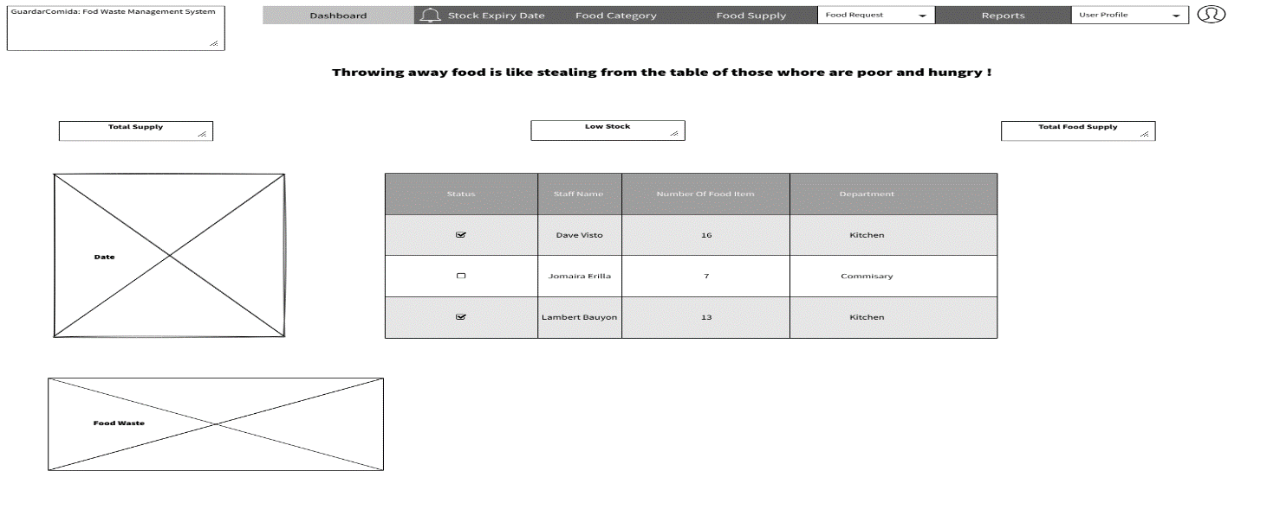

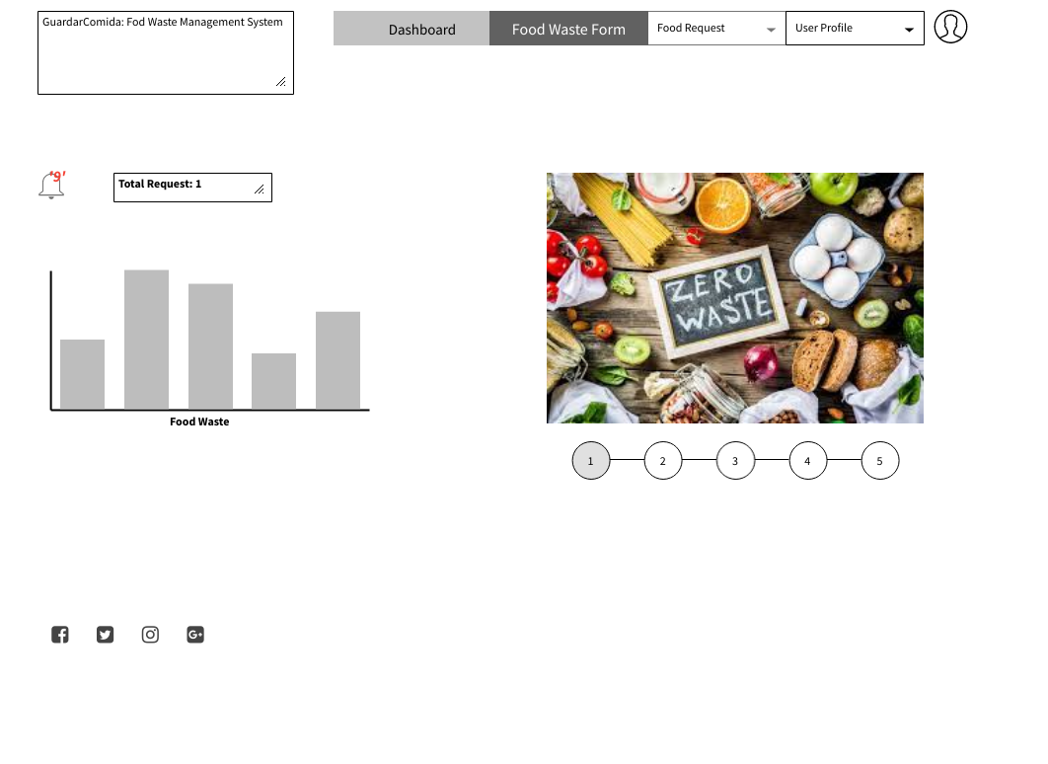**Staff Interface**

Front End Software: Sublime Text 3, Web Browser

Back End Software:  XAMPP

## Hardware Interfaces

For hardware interfaces that the group will be using is the computer or laptop in the product creation and as well as in accessing the websites in web browser by using the HTTP communication protocol.

## Software Interfaces

*The system will be linked to other software components such as the XAMMP MYSQL database version 7.4.20, which will be responsible for the container or storage of our data inputs using the system. It will also serve as a way to connect login form to user interfaces.*

## Communications Interfaces

The requirements associate with the products is web browser for accessing and viewing websites or the developed product. And the communication standards that will be used is the HTTP or the Hypertext Transfer Protocols that allows user to communicate and transfer data on the World Wide Web.

# Other Nonfunctional Requirements

## Performance Requirements

The system analysis will provide the requirements for the system and to check if the system working properly. Conducting software testing in other groups to know what features that can easily for them to use or to perform a job easily with no hesitation and hassle.

## Safety Requirements

The possible loss or damage of the system is the overload of data input in the database, interruption in losing connection while inputting data in the system, this must be prevented by always have a backup for the data while typing when the website or the system reload the data input are saved.

## Security Requirements

The system must only access by the employee in a restaurant or hotel, it also has an authentication prompt to those people who tried to access the system that are not employed in the organization.

## Software Quality Attributes

The quality characteristics of the product that will be important to either the customers or developers are system reliability, usability, and functionality. Reliability for the correct performance of the system at the specific time so it will not cause a problem to the user and developer. Usability so the product will be usable to the users. Lastly, the functionality define the behavior of the system. If the system is functional it will benefit both the user and developers and will not cause problem to them.

# Other Requirements

Database is one of the important components of the system because its function is to hold the data. It is the storage of data and information that the user store in it wherein the user can retrieve, modify, and delete data based on the data-processing operations. A database management system (DBMS) extracts information from the database in response to queries. It uses a combination of one-to-one, one-to-many, many-to-many connection to create multiple queries.

**Appendix A: Glossary**

**Admin** - a person legally vested with the right of administration of an estate.

**Business Process** - A business process refers to a wide range of structured, often chained, activities or tasks conducted by people or equipment to produce a specific service or product for a particular user or consumer.

**Convenien**t - fitting in well with a person's needs, activities, and plans.

**Crew** - a group of people who work on and operate a ship, boat, aircraft, spacecraft, or train.

**Food Waste Management** - refers to food appropriate for human consumption being discarded, whether or not after it is kept beyond its expiry date or left to spoil.

**Functionality** - the quality or state of being [functional](https://www.merriam-webster.com/dictionary/functional).

**Hospitality service** - taking care of your guests and anticipating their needs and it is the relationship between the guest and the host, or the act or practice of being hospitable. This includes the reception and entertainment of guests, visitors, or strangers.

**Hygienic standard** - the most reliable basis for infection control. It comprises surface disinfection and cleaning, reprocessing of medical devices, and the use of protective clothing.

**Inventory** - a complete list of items such as property, goods in stock, or the contents of a building.

**Leftover food** - something that remains unused or unconsumed foods.

**Monitoring** - observe and check the progress or quality of (something) over a period of time

**Policies** – a set of rules or guidelines for your organization and employees to follow in or to achieve a specific goal.

**Prevent** – keep (something) from happening or arising.

**Protocol** - the official procedure or system of rules governing affairs of state or diplomatic occasions.

**Regulatory Policies** - about achieving government's objectives through the use of **regulations**, laws, and other instruments to deliver better economic and social outcomes and thus enhance the life of citizens and business.

**Reliability** – the quality of being trustworthy or of performing consistently well.

**Stocks** – a supply or quantity of something accumulated or available for future use.

**Supply** - a stock of a resource from which a person or place can be provided with the necessary amount of that resource.

**Usability** - a measure of how well a specific user in a specific context can use a product/design to achieve a defined goal effectively, efficiently and satisfactorily.

**Wastage** - the action or process of losing or destroying something by using it carelessly or extravagantly.

**Appendix B: Analysis Models**

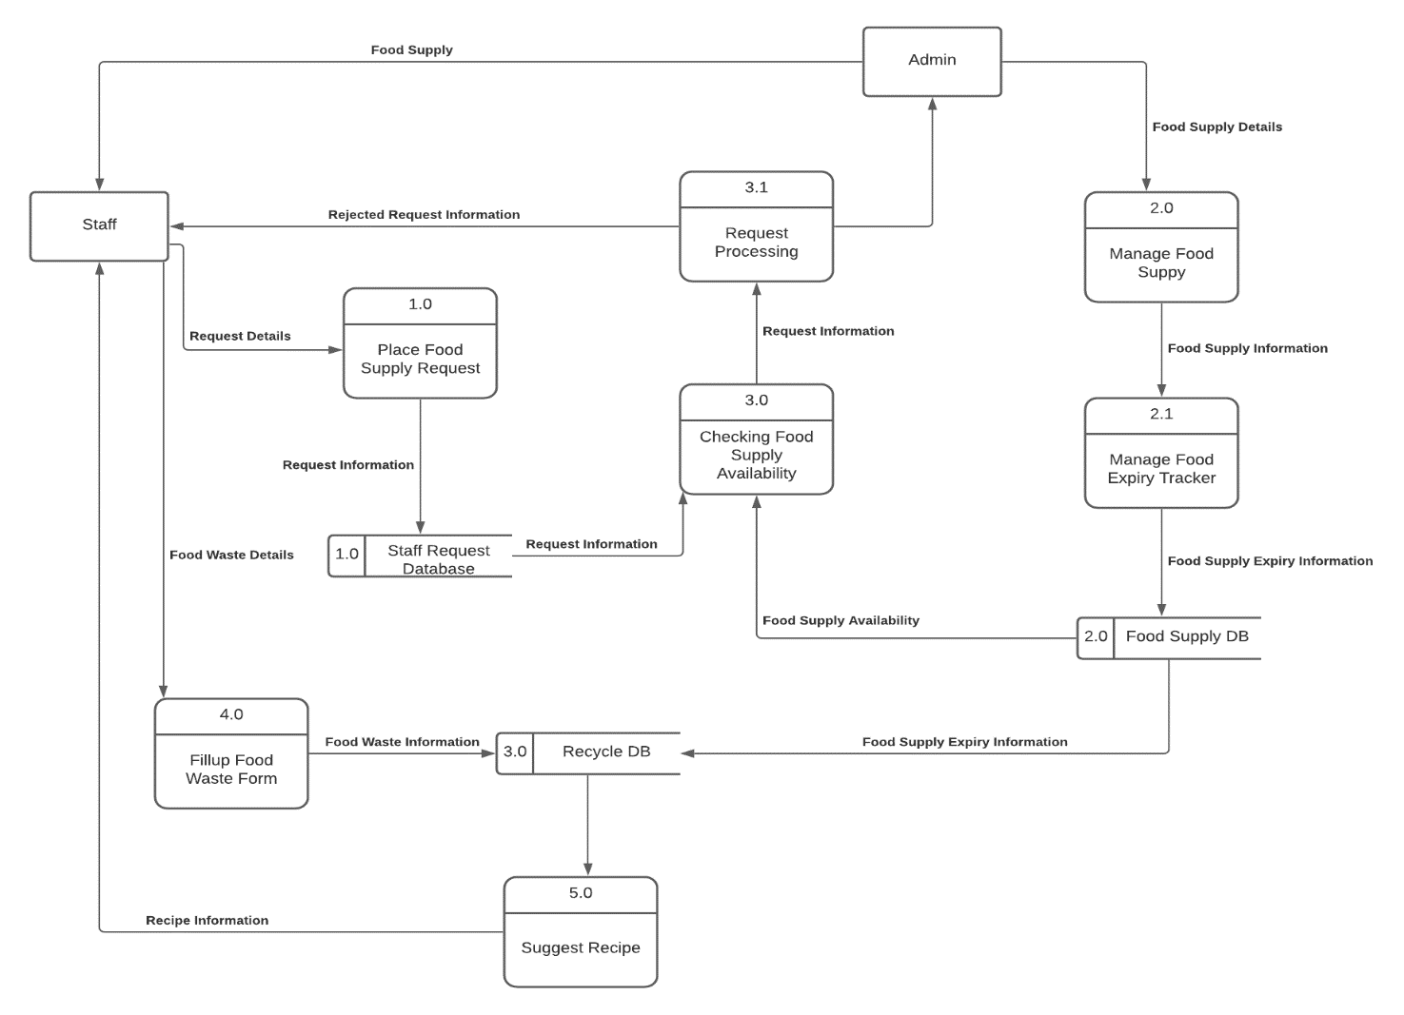

**Appendix C: Issues List**

The list of issues we see that need to be resolve are:

* Pending development of other features
* Problem in the functionality of some features
* Connection of database for some features
* System Design Enhancement